**What is play therapy?**

Play is the natural language of children and is a metaphor, or symbolic expression, of what is going on in their lives.

Early childhood experts agree that play is essential and facilitates:

* Expressive language
* Communication skills
* Emotional development
* Social skills
* Cognitive development
* Decision-making skills

Play therapy offers opportunities for self-expression and personal growth in a safe, non-judgemental environment.

If play is considered the language of children, then toys are their words.

Children in play therapy are able to choose from a range of toys and activities including sand, paint, clay, music, puppets, storytelling and role-play. They are given the power to determine what toys to use and how to use these toys.

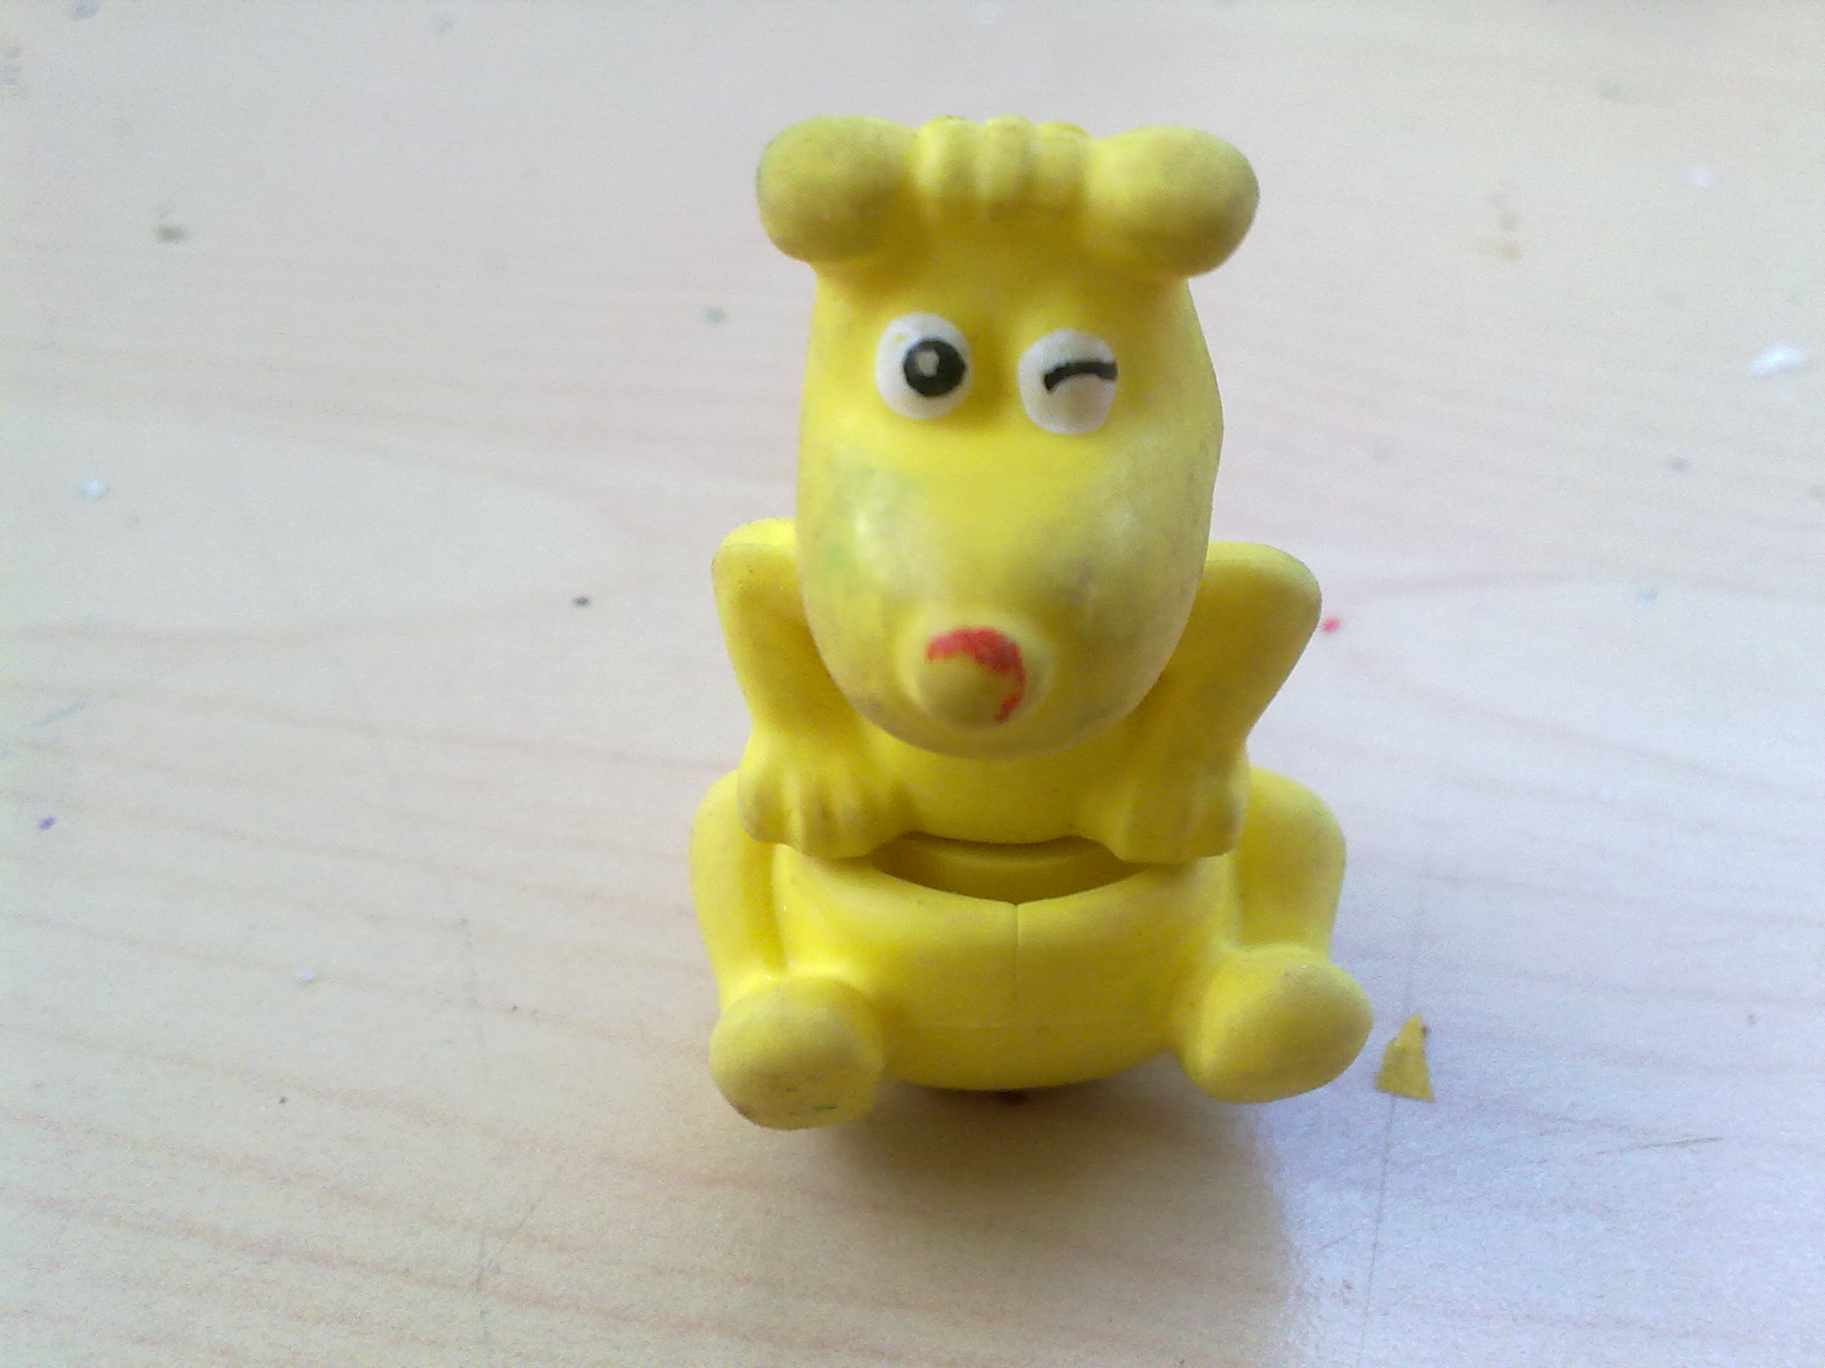

*Data Collected from clients 2010-2016

**The Role of Parents**

Parents/Carers are the most important adults in their child’s life.  It makes sense for parents/carers to be actively included in the therapeutic process of

play therapy.

Parents/carers play a vital role in accurate assessment and successful outcomes.

Parent consultations create opportunities for parents/carers to gather information about their child’s needs and learn new ways to help their child be successful at home and at school.

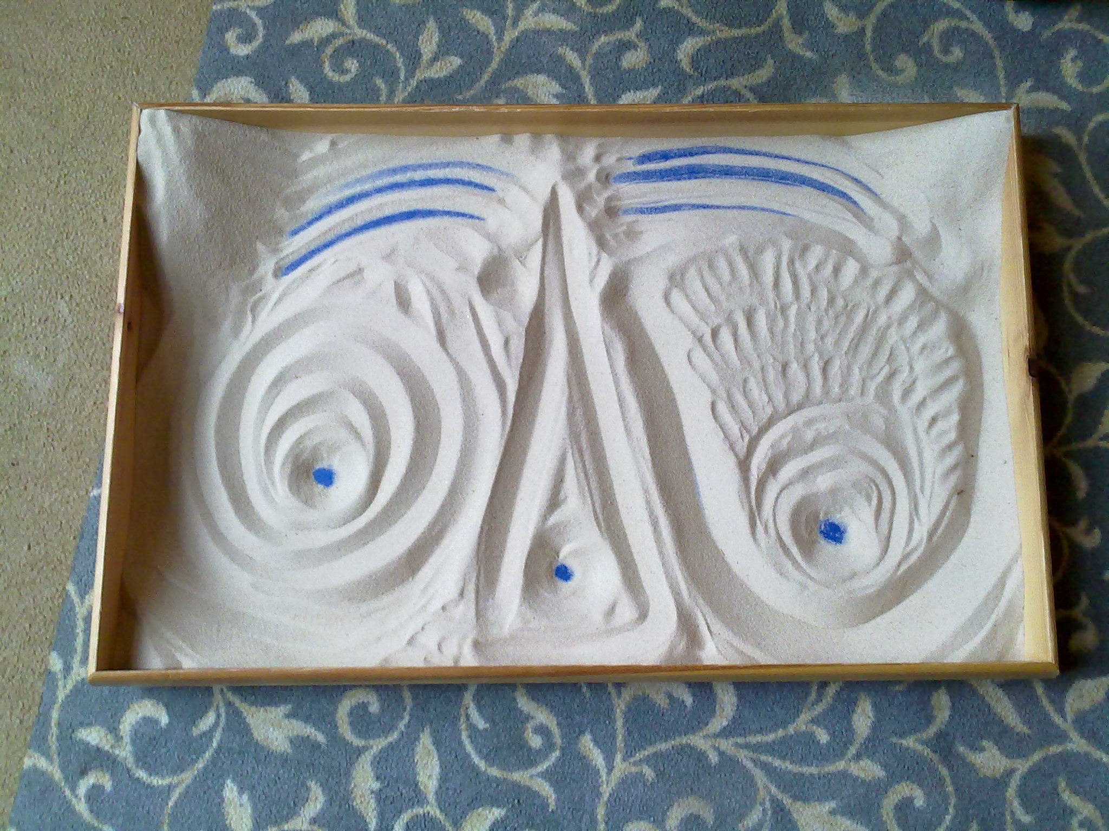

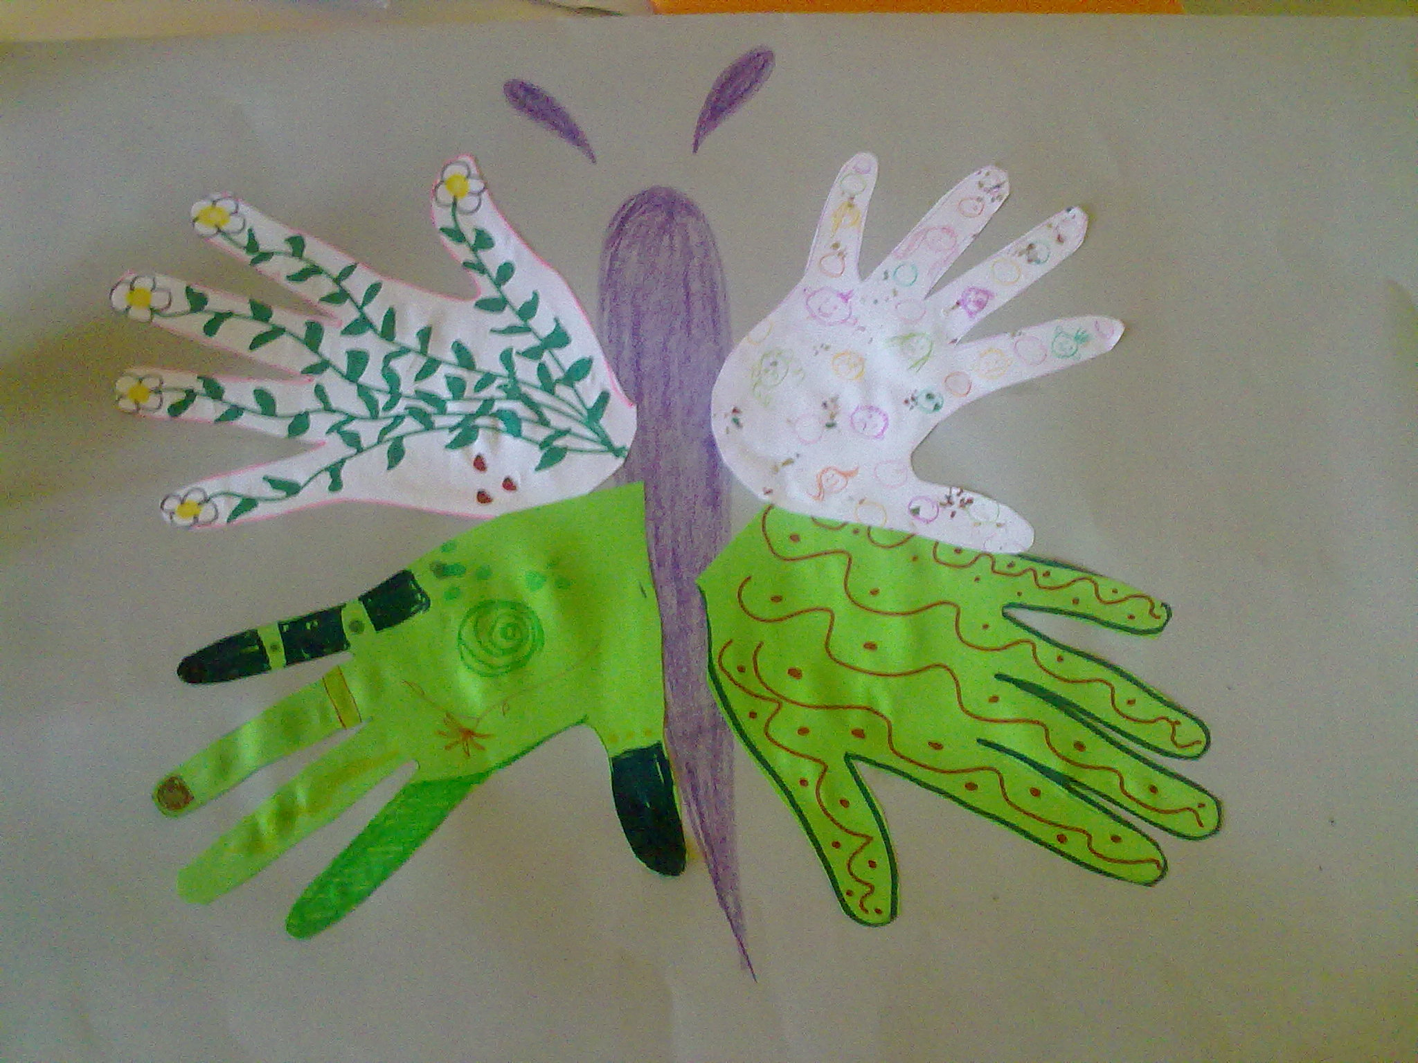

**Who can benefit?**

Growing up brings many changes and challenges for a child. Sometimes children may need a little help understanding and dealing with these changes.

Research findings support the effectiveness of play therapy for a variety of social, emotional, educational, and behavioural concerns including, but not limited to:

* Anxiety/nervousness
* Anger and aggression
* Low self-esteem/confidence
* Poor concentration
* Difficulty in making friends

Play therapy is also helpful for children experiencing difficult life situations such as divorce, grief, relocation, illness or disability, domestic violence or abuse.

87% of children referred to me for play therapy have shown an improvement in their behaviour*

Catriona Irvine,

Certified Play Therapist (MA)

[cat@therapeuticplayservices.co.uk](mailto:cat@therapeuticplayservices.co.uk)

Tel: 07487 790443